National University of Computer and Emerging Sciences



Laboratory Manual

For

Programming Fundamentals

|  |  |
| --- | --- |
| Course Instructor | Mr. Farooq Ahmed |
| Lab Instructor(s) | Ms. Shamsa Kanwal  Mr. Shoaib Hasnat |
| Section | PF A |
| Semester | Fall 2019 |

Department of Computer Science

FAST-NU, Lahore, Pakistan

# Lab Manual 09

# Introduction

## Objectives

After performing this lab, students shall be able to:

* Write C++ Code for the problems involving if/else, Functions, nested while/For loop and arrays

## Quiz

Write a function isPrime(int n) to test whether a parameter is prime. Write another function Fibonacci(int n) which calculates the nth Fibonacci number. Write a main program that uses these functions to print out the first 5 fibonacci numbers that are also primes.

## Problems

**Task 1**

In this task you implement a function of insertion sort algorithm .Insertion sort is based on the idea that one element from the input elements is consumed in each iteration to find its correct position i.e., the position to which it belongs in a sorted array. It iterates the input elements by growing the sorted array at each iteration. It compares the current element with the largest value in the sorted array. If the current element is greater, then it leaves the element in its place and moves on to the next element else it finds its correct position in the sorted array and moves it to that position. This is done by shifting all the elements, which are larger than the current element, in the sorted array to one position ahead.

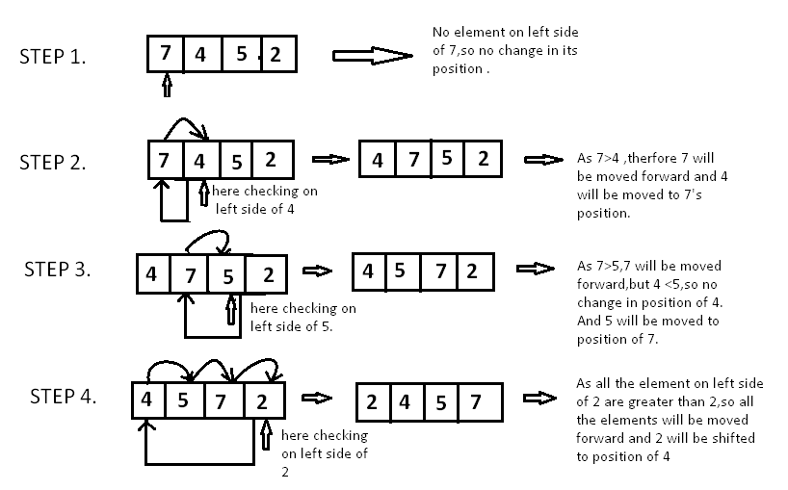

**Task 2**

Write a program that simulates a lottery. The program should have an array of five integers named lottery and should generate a random number in the range of 0 through 9 for each element in the array. The user should enter five digits, which should be stored in an integer array named user. The program is to compare the corresponding elements in the two arrays and keep a count of the digits that match. For example, the following shows the lottery array and the user array with sample numbers stored in each. There is only one matching digits (elements 3 ).



The program should display the random numbers stored in the lottery array and the number of matching digits. If all of the digits match, display a message proclaiming the user as a grand prize winner.

Note

For random number you can use this code

#include <cstdlib>

int r = (rand() % 9) + 1;

**Task 3**

Task -3: Driver’s License Exam The local Driver’s License Office has asked you to write a program that grades the written portion of the driver’s license exam. The exam has 20 multiple-choice questions. Here are the correct answers:

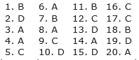

Your program should store the correct answers shown above in an array. It should ask the user to enter the student’s answers for each of the 20 questions, and the answers should be stored in another array. After the student’s answers have been entered, the program should display a message indicating whether the student passed or failed the exam. (A student must correctly answer 15 of the 20 questions to pass the exam.) It should then display the total number of correctly answered questions, the total number of incorrectly answered questions, and a list showing the question numbers of the incorrectly answered questions.